Autism and Hospitality

A Life-Enabling Opportunity With Weekly Support

September 2015 – February 2016

Published by Kris Bravo on July 24th, 2016

Email – [kris.bravo@gmail.com](mailto:kris.bravo@gmail.com)

github.com/bravok/hospitality-autism-model

# Table of Contents

Table of Contents 1

Introduction 1

Life Goals 2

Autism And Life Goals 2

The Hotel 2

The Funded and Converted Hotel Suite as an Residential Autism Community 3

Life Enablement Scenario: Weekly Support 5

The Lifecycle of the Hotel as an Autism Residence 6

Conclusion 10

References 10

# Introduction

Children diagnosed with Autism receive a variety of support from an ecosystem of charitable and government programs. As they grow, other special needs programs join in to focus on the goals appropriate for the child’s stage of life and challenges. At some point though, the child becomes an adult, these resources give way, and the parents or other caregiver assume the majority of responsibility. If all goes well, the adult continues to receive support until the end of their lives. If the caregivers run out of resources or pass away the problems increase dramatically.

It is difficult for people caring for an Autistic child or adult to reset their line of thinking back to the aspirations that everyone has; Freedom, passion, purpose, and orderly living are arguably the best of what life has to offer.

If you take a step back, out of the challenges of ASD, and into the world of the hospitality industry, you will find a community of people focused on ensuring that a brief moment in a guest’s life is as pleasant as possible. Although the goal is running a profitable business, the hotel property itself is also tuned to this functional purpose. Moreover, the business must operate in compliance with laws addressing safety, security, and disabilities.

Provided sustained sources of revenue, a hotel can serve as a residence for autistic adults with remarkable results. And when the time comes, the same property can be returned to its original purpose, so as not to create an immovable place serving a noble but singular and potentially unsustainable purpose.

Here is a proposed approach.

# Life Goals

A person’s life is driven by their goals and experiences. The well-rounded life flourishes in a variety of ways. Here, we consider four that are commonly referred to in history and culture.

## Freedom

Each of us needs the ability to associate with others and pursue happiness without unnecessary limits.

## Passion

We can then begin to develop the relationships that are important to us, devote time to the things we care about, and express ourselves creatively.

## Purpose

In doing so, we find our reason for being, whether through vocation, talent, or other avenues.

## Orderly Living

This is best achieved lawfully, without harming or inhibiting others, and within the larger community.

# Autism And Life Goals

Autism comes with a pervasive disruption of all of these goals. It interferes directly with liberty, suppresses expression of wants and desires, and limits opportunities to find purpose. Sensory overload and atypical behaviors seem disruptive from the outside, and are often perceived as threats to others.

For the adult with Autism, all of life’s goals are under duress.

# The Hotel

The hotel is a well-designed ecosystem. As a commercial business, the goal is to generate revenue by keeping guests happy and returning, and by maintaining maximum occupancy with the highest nightly rates possible. There are a large number of supporting companies that design, renovate, operate, supply and service hotels. The market is competitive, with costs kept as low as possible while maintaining value. Each hotel’s design varies by size, location, layout, and interior design. The required employee roles, the level of housekeeping, the food services provided, and disability regulations such as ADA all influence the design as well.

## Size

The size of a hotel is driven by the forecasted demand from surrounding attractions and businesses. It is very common to see hotels with 40 to 80 rooms, which is a suitable range to provide homes for 20 to 30 residence that each need two rooms.

## Location

A hotels location is usually near other businesses, unless it is itself an attraction.

## Layout

Inside, the room layouts are driven by a combination of target market, design constraints, and expected length of stay of the guests. Of particular interest here are suites with kitchenettes, separate bedrooms, and direct doors to adjacent rooms.

## Interior Design (Furniture, Fixtures and Equipment)

Hotel room designs follow regulations and are designed with periodic renovations in mind. Furniture, fixtures and equipment (FF&E) can be ordered by room count and make efficient use of space.

## Roles

The property is designed with service and support roles squarely in mind. Break rooms, back-office space, laundry facilities, a kitchen, and service elevators are all built into the plan. These support the various people required to operate the hotel. Relevant roles include front-desk, housekeeping, management, maintenance, and engineering.

## Housekeeping

The property is built with laundry service, cleaning facilities and adequate storage. Elevators and hallways are large enough for cleaning and laundry carts to travel without otherwise blocking access. Rooms are consistent and easy to clean.

## Food and Beverage

Hotel properties designed with suites typically have a central food prep kitchen. Kitchenettes within the room also have basic appliances.

## ADA Compliance

The Americans with Disabilities Act was introduced in 1990 to protect people with disabilities from discrimination. Compliance is an obligation of all hotels operating within the United States. As a result, properties have accessible rooms, swimming pool lifts, visual alarms, open showers, and thresholds that accommodate wheelchairs and other features.

# The Funded and Converted Hotel Suite as an Residential Autism Community

When you combine the following,

* the varied needs of autistic adults
* the existing infrastructure in the hotel suites property
* a revenue generating business

the result is a viable residential community. Looking back on the life goals described earlier, Figure 1 shows how each of these is supported by the combination of a hotel property and a business to fund it. The dark area of the circle shows overlap between life goals and hotel characteristics. These overlaps result in a list of opportunities, some of which are described below.

## Macintosh HD:Users:kris:Documents:personal:2015:Project Lakshmi:herox:imagery:Screen Shot 2016-02-23 at 5.14.49 AM.pngVariation In Support Levels

(Liberty, Orderly Living)

The model residence is intended to accommodate all levels of need for support. Although each adult reaches a certain level of independent living, there are life events that can change this very quickly. Illness, accidents, surgery, aging, and other causes can temporarily or permanently change the level of support a resident requires.

## Transportation

(Liberty, Wants, Purpose)

Hotels are typically built with a check-in carport for unloading and loading bags. This is a good fit for both shuttling people who are unable to drive, and to deflect weather for those that need additional time to enter and leave a vehicle.

Figure 1: Life Goals and the Hotel

As a large residence, it’s economically sensible to have a shuttle bus for the property.

## Diet

(Wants, Orderly Living)

Hotels also have central kitchens and others food prep areas. Hotel Suites have kitchenettes that will support more independent adults. The hotel kitchen can also be used to teach independent food preparation.

## Communication

(Liberty, Wants, Orderly Living)

Hotels are constructed with central phone systems and Internet infrastructure.

## Interaction

(Liberty, Wants, Orderly Living)

Both the community and the on-property business create opportunities to interact with others. When the activity gets excessive, the resident can retreat to his or her own space to recover. Group travel to local attractions would be manageable as well. Repurposed meeting rooms provide space for celebrations or group events.

## Vocation

(Liberty, Wants, Purpose, Orderly Living)

The on-premise business and the off-premise revenue businesses create additional opportunities for the employable residents to learn a profession.

## Health

(Liberty)

Dietary needs can be supported with the in-suite kitchenette and the central kitchen.

Fitness is supported with group activity and a converted fitness center.

## Safety

(Order, Freedom)

Hotels comply with hospitality and business safety regulations. Sprinkler systems, fire alarms, security cameras, and regular maintenance help provide safety.

## Finances & Legal Matters

(Liberty, Wants, Orderly Living)

Residential operations require financial management and bookkeeping. Since the residence is relatively small, the staff accountant will also serve to assist with basic bookkeeping for residents needing assistance. Legal support for the community will also address special needs trusts, wills and other personal matters.

## Conduct

(Liberty, Orderly Living)

The hotel-based residence with on-premise and off-site businesses provide opportunities to watch and learn. If the on-premise space were leased to an autism therapy center, behavior improvements would be directly supported.

# Life Enablement Scenario: Weekly Support

## Joining the community

The higher functioning adults can join the residence by completing an application similar to leasing an apartment. Usually they would require assistance and help with initial funds. A personal living plan would describe their needs and help determine the appropriate suite and adjacent rooms.

## Living Configuration

Below is an example floor plan pairing a suite with kitchenette and a single bed guest room. It’s possible that the property would have adjoining rooms, but this would be an optional feature for the adult requiring only weekly support.

Macintosh HD:Users:kris:Downloads:2015-11-08 Autism & Hospitality, Weekly Assistance Floor Plan.png

Figure : Weekly Support Room Configuration

## Daily Living

The resident’s routines and tasks are mainly up to them. Periodically they would participate in group-outings, meet with the community financial assistant, take a shuttle to doctor appointments, and the rest of life’s tasks. All of the typical characteristics of community living prevail – residents requiring higher levels of direct support would receive it primarily in their own suites.

## Employment

The resident can apply to work or intern at one of the residence’s businesses when a position is available. If the resident already works at a different location or graduates from the internship program, shuttle service would be available to get to and from work. The financial assistant would be able to help set up direct deposit into a special needs trust, retirement or other investment account.

## Cleaning

Those individuals who haven’t learned how to keep their home clean would receive coaching or housekeeping assistance. Access to shared washers and dryers would encourage socializing. These appliances would not be an option within the suite, since this isn’t typical of a hotel, but a central industrial wash would accommodate large blankets and other special cleaning cases (biomedical for example).

# The Lifecycle of the Hotel as an Autism Residence

The residence lifecycle is core to the hospitality-based model. Unlike other community residences, this residence seeks to lower the barrier to entry, defer dependence on government or charitable assistance, and incorporate vocational training paths. This is done by extending the lead-time to start the community, establishing revenue generators, using existing infrastructure with strong alignment to ASD needs, and maintaining the hotel as an asset that can be sold later in the larger hospitality real-estate market.

## Discovery

The community begins with the need and preplanning by a parent/advocate-based committee. The committee identifies seed funding, incorporates as a non-profit, reviews the residence model proposed here, and makes alterations fitting for the scenario.

After settling on the approach, the committee works to capitalize the residence and identify the off-premise, on-premise and other revenue streams of the residence. The founders will likely have work and business experience that can help identify appropriate businesses.

## Purchase

Years prior to the planned opening date, the committee seeks out the banking relationship and equity partnerships necessary to finance the residence. This time is also used to identify candidate properties and businesses. Extended stay properties and hotels with suites are ideal real-estate opportunities. Often times a hotel for sale needs a Property Improvement Plan (PIP) executed; this represents an ideal time for a residential conversion. The deal is comprised of the following components:

1. The non-profit community organization
2. The property ownership corporation
3. The capital structure
4. The hotel property
5. The on-premise business
6. The off-premise business and owning corporation

## Example Hotel Sale Listings and Financial Balance

The following list includes example hotels recently listed for sale that fit the general criteria for operating as an autism residence. Sale prices are rounded; annual expenses and other costs are speculative, but believed to be in line with the costs that would be observed.

The annual profit target represents the net income required from the off-premise business to sustain operations and keep leasing costs down.

### 68 room hotel & suites, 1st floor autism therapy center, off-premise fast food restaurant

Oxford, North Carolina

**# Residents**: 30

**Sale price**: $3.5 million ($50k per room)

**Annual expenses**: $500k ($7.4k per room)

**Annual Residence Leasing**: $200k ($6.7k per resident)

**1st Floor Lease**: $80k

**Off-premise Business Annual Profit Target**: $220k

### 42 room hotel and suites, 1st floor small business offices, off-premise car wash

Monroeville, Alabama

**# Residents**: 20

**Sale price**: $2.5 million ($60k per room)

**Annual expenses**: $430k ($10.2k per room)

**Annual Residence Lease**: $120k ($6k per resident)

**1st Floor Lease**: $70k

**Off-premise Business Annual Profit Target**: $240k

### 62 room hotel & suites, 1st floor IT certification testing center, off-premise hotel with food & beverage

Columbus, Georgia

**# Residents**: 30

**Sale price**: $2.5 million ($40k per room)

**Annual expenses**: $500k ($8.1k per room)

**Annual Residence Lease**: $180k ($6k)

**1st Floor Lease**: $60k

**Off-premise Business Annual Profit Target**: $260k

## Conversion

Transforming the hotel into the adult community residence is another area where the key tenets of this model are critical. Contractors used to prepare the property should be familiar with hospitality renovation and generally follow the appropriate guidelines, so that any changes made do not invalidate the use of the property as a hotel in the future. Otherwise, a questionnaire about the furniture, fixtures and equipment (FF&E) for the specific residents is used to design the room interior. The resident profile (Weekly, Daily or 24/7 support) determines the room combination (adjacent room, adjoining suite, etc.).

## Operation

Figure 3[1] shows how three key revenue streams fund the community. Primary revenue may come from the disability benefits of the residents. The secondary revenue comes from the off-premise business. This business also serves as the primary vocational training program for the residence. First floor leasing and leasing of additional rooms provide supplemental income as well. Examples of operating expenses are listed, including care, therapy, insurance maintenance and housekeeping.

The non-profit corporation focuses on the health of the combined balance. Personal income is separate from funds to operate the residence.

All maintenance is performed according to hospitality standards and using the industry ecosystem when possible. For example, if hospitality ADA compliance requires a sink height of 48” but the ideal height for the resident would be 50”, 48” should be applied. Deviations should be accumulated for regular review, to make sure the property can still be practically converted back to a hotel.

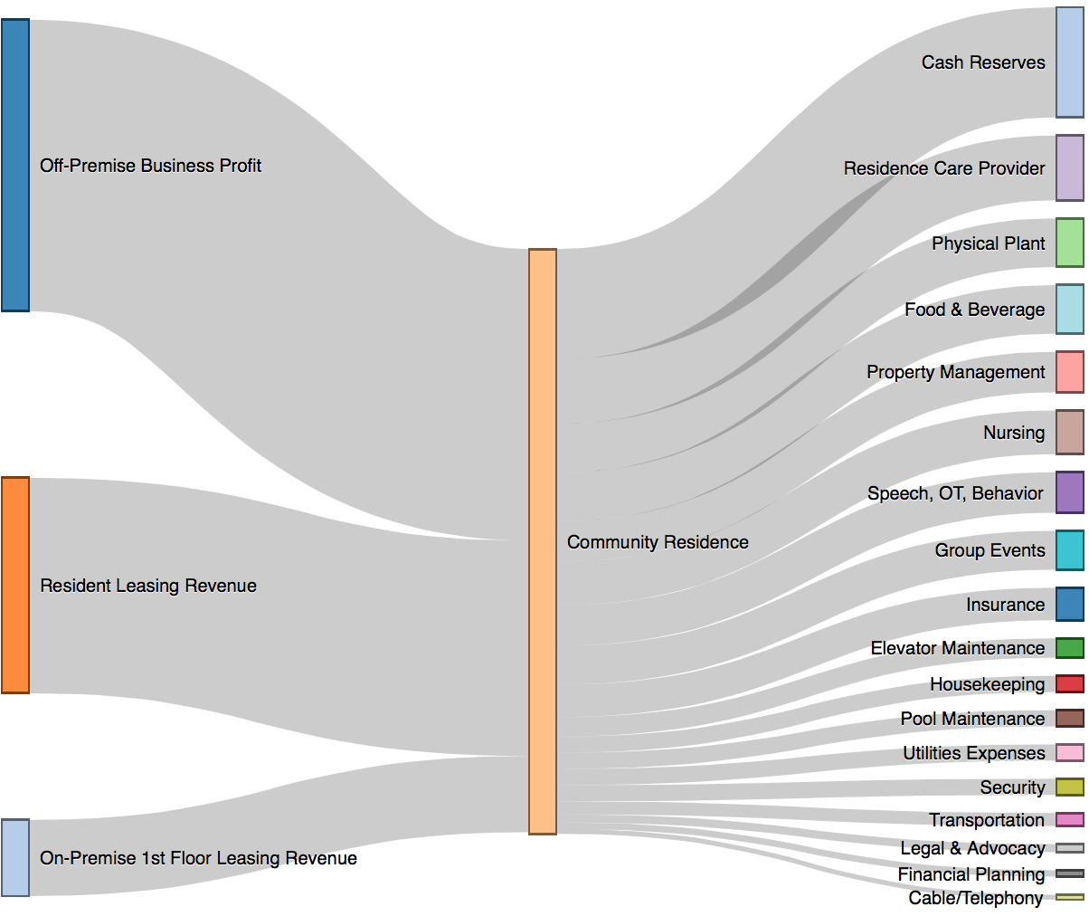

Figure : Community Residence Cash Flow

## Hotel-Ready Audits

Periodically the community board will engage a hospitality renovation contractor to assess the viability of the property as a hotel. Any issues found – for example, code violations, deviations from ADA guidelines for hospitality – shall be remedied or logged in a master list. Estimates shall be obtained for remedies not executed, so that the community is fully aware of the cost associated with divesting the property to move or disband the community.

## Reinstatement of Hotel

At some point in the future the residence non-profit and occupants may decide to sell the property and relocate or disband the community. Preparation of the property would focus on three factors:

* Remove furniture, fixtures and equipment specific to the community members
* Prepare the spaces to bring them to an acceptable resell level.
* Reset any changes to the property that were logged as deviations from its nature as a hotel, but necessary at the time. Examples include additional security, door lock changes, and recreational spaces.

### Sale

The property sale settles the financing, repays equity partners, and returns the balance to the community for the next location. If the community is dissolved, the remaining funds are distributed to the community member special needs trusts to help with their next home.

# Conclusion

Adults with ASD often require occasional support throughout their lives. This need does not preclude them from having typical life goals. Hospitality is an industry where supporting the needs of guests is fundamental. Here we combine the autistic adults experience, a converted hotel suites, and a sustainable funding structure, without creating a lifelong institution. This residential living model focuses on freedom, passion, purpose, and orderly living as worthwhile and attainable goals for the adult requiring weekly support.

## Notes on a Pilot

It is unlikely that a 12-month pilot period would be sufficient to launch a community fitting this model in all aspects. However, two test cases could be used to prove out the viability:

1. A multi-month group reservation of an existing hotel with participating adults and caregivers.
2. A business plan with a complete financial analysis and pro-forma, using references to an existing property and nearby business.

# References

1. "Lakshmi." Wikipedia: The Free Encyclopedia. Wikimedia Foundation, Inc. 16 Feb 2016. Web. 20 Feb 2016.
2. “Autism Speaks House To Home Prize.” Herox Website. Autism Speaks. 11 Sept 2015. Web. 20 Feb 2016. <<https://herox.com/HouseToHomePrize>>
3. Americans With Disabilities Act of 1990. Pub. L. 101-336. 26 July 1990. 104 Stat. 328.

1. Ratios not to scale – some expenses hidden for presentation purposes – taxes, etc.